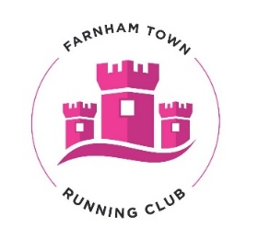
TRIAL MEMBERSHIP APPLICATION FORM
Welcome to your two-week trial of Farnham Town Running Club, Please complete all details in block capitals and return to MEMBERSHIP@FARNHAMTOWNRUNNINGCLUB.CO.UK or hand to one of the Run Leaders.

RUNNER DETAILS

First Name |  |  |  |  | Surname
Address
 |  |  |  | Postcode
Gender |  |  |  | Preferred contact number
Date of Birth  DD/MM/YY |  |  |  | Email Address*

EMERGENCY CONTACT
Emergency Contact name:
Phone number |  | Relation

MEDICAL INFORMATION

Please detail below any important medical information that our Run Leaders should be aware of (e.g., epilepsy, asthma, diabetes, allergies, etc.) Please do not leave blank – if there is no information please write ‘None’.

I consent to my medical information to be shared with coaches for the purposes of the delivery of my safe participation in club activity. This data will not be shared or processed for any other purpose.

SECTION F: PRIVACY STATEMENT

Farnham Town Running Club take the protection of the data that we hold about you as a prospective member seriously and will do everything possible to ensure that data is collected, stored, processed, maintained, cleansed, and retained in accordance with current and future UK data protection legislation.

Please read the full privacy notice carefully to see how The Club will treat the personal information that you provide to us. We will take reasonable care to keep your information secure and to prevent any unauthorised access.

Please note: Should you chose to not apply for membership with the club, your details will be destroyed.

SECTION H: DECLARATION

By returning this completed form, I confirm that after two sessions running with the club, I will be able to decide if an application for membership is appropriate for me.

Signature
Print Name
Date

Farnham Town Running Club – The Memorial Ground, Mead Lane, Farnham, Surrey, GU9 7DY

